**Various Connection Architectures**

There are the following two types of connection architectures:

1. **Connected architecture:** the application remains connected with the database throughout the processing.
2. **Disconnected architecture:** the application automatically connects/disconnects during the processing. The application uses temporary data on the application side called a DataSet.

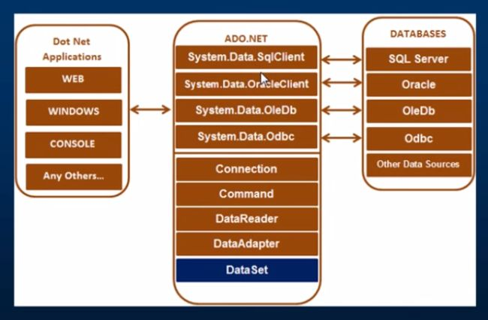

## Important Classes in ADO.NET

We can also observe various classes in the preceding diagram. They are:

1. Connection Class
2. Command Class
3. DataReader Class
4. DataAdaptor Class
5. DataSet.Class

### 1. Connection Class

In ADO.NET, we use these connection classes to connect to the database. These connection classes also manage transactions and connection pooling. To learn more about connection classes, start here: [Connection in ADO.NET](https://www.c-sharpcorner.com/article/exploring-connection-in-ado-net/).

### 2. Command Class

The Command class provides methods for storing and executing SQL statements and Stored Procedures. The following are the various commands that are executed by the Command Class.

* **ExecuteReader:** Returns data to the client as rows. This would typically be an SQL select statement or a Stored Procedure that contains one or more select statements. This method returns a DataReader object that can be used to fill a DataTable object or used directly for printing reports and so forth.
* **ExecuteNonQuery:** Executes a command that changes the data in the database, such as an update, delete, or insert statement, or a Stored Procedure that contains one or more of these statements. This method returns an integer that is the number of rows affected by the query.
* **ExecuteScalar:** This method only returns a single value. This kind of query returns a count of rows or a calculated value.
* **ExecuteXMLReader:** (SqlClient classes only) Obtains data from an SQL Server 2000 database using an XML stream. Returns an XML Reader object.

### 3. DataReader Class

The DataReader is used to retrieve data. It is used in conjunction with the Command class to execute an SQL Select statement and then access the returned rows.

### 4. DataAdapter Class

The DataAdapter is used to connect DataSets to databases. The DataAdapter is most useful when using data-bound controls in Windows Forms, but it can also be used to provide an easy way to manage the connection between your application and the underlying database tables, views and Stored Procedures.

### 5. DataSet Class

The DataSet is the heart of ADO.NET. The DataSet is essentially a collection of DataTable objects. In turn each object contains a collection of DataColumn and DataRow objects. The DataSet also contains a Relations collection that can be used to define relations among Data Table Objects.

3-tireArchitecture

